Tableau Dashboard

# Part 1:

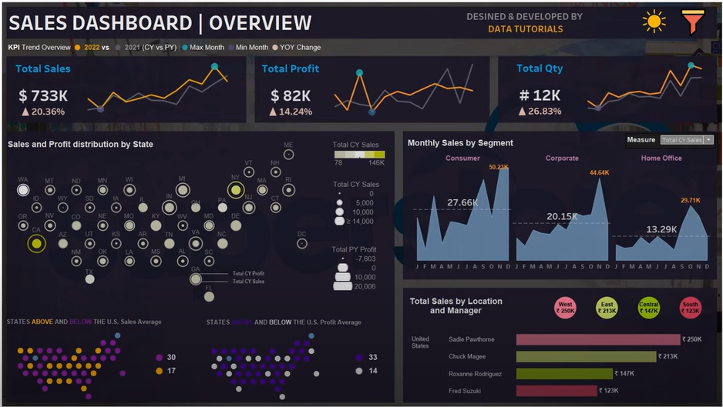

S

CHECK FOR ACCOUNTING KPI Metrics:

Metrics:

Total CY Sales (Calendar year)

Total PY Sales (Previous Year)

YOY Sales (Year-Over-Year Sales)

## Chart colour:

KPI

Heading: Font Tableau Bold – 14 Color: Light Green

KPI Value: Font Tableau Bold – 20 Color: Black

YOY Value: Font Tableau Bold – 12 Color: Light Pink Red